Lab 5
Name: JISHNU SIVAKUMAR SRN: PES2UG24CS204

ISSUES
Issue | Type | Line(s) | Description | Fix
Hard-coded password | Security | 5 | Password stored in source. | Removed the unused constant.
SQL query construction | Security | 9 | Values inserted into SQL using an f-string. | Used SQL placeholders and parameters.
Mutable default list | Bug | 8 | A default list could be shared between calls. | Used None and created a list inside the function.
Function name | Style | 8 | addDue did not follow snake_case. | Renamed it add_due and updated calls.
Missing return | Bug | 12–16 | collect() had no explicit return for a missing record. | Added return None.
Broad exception | Reliability | 22 | Catching Exception could hide unrelated errors. | Caught specific exception types.
None comparison | Style | 29 | Compared rows with None using !=. | Changed it to is not None.
Spacing / long lines | Style | 4, 12–15 | Spacing and line length warnings. | Improved spacing and split some lines; two E501 warnings remain.

REPORTS before and after fix:

PYLINT:

beofre after:
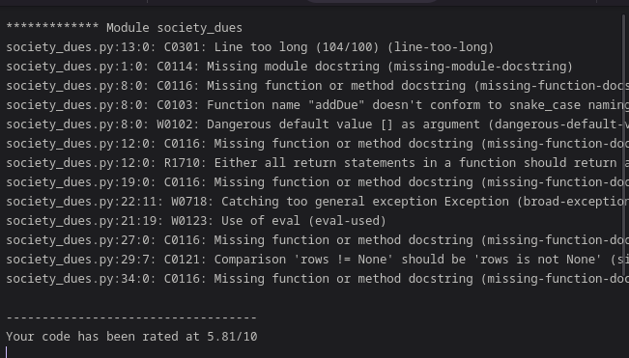
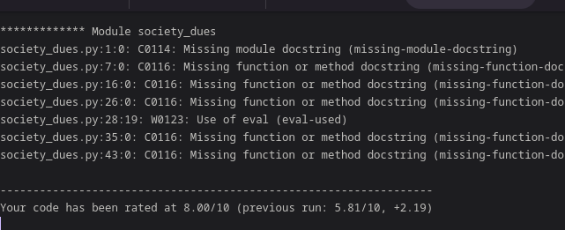

FLAKE8:
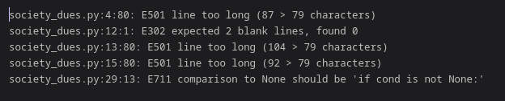
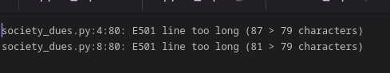

BANDIT:
